APARTAT B:

|  |  |  |  |  |
| --- | --- | --- | --- | --- |
|  | Logistic | SVM | KNN | Decision Tree |
| 50% train | 0.9775 | 0.9887 | 0.9775 | 0.8988 |
| 80% train | 0.9722 | 0.9722 | 0.9166 | 0.8888 |
| 70% train | 0.9814 | 0.9629 | 0.9814 | 0.9629 |

PR DECISION TREE

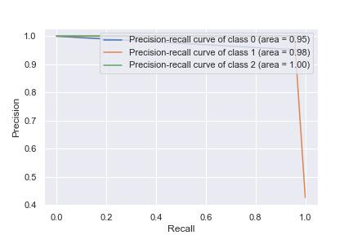

PR KNN

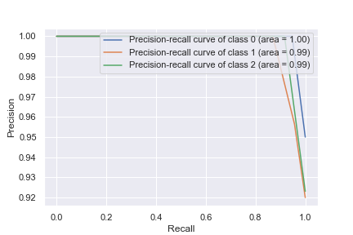

PR LOGISTIC REGRESSION

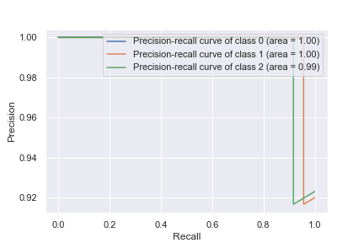

PR SVM

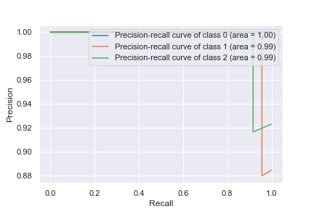

ROC DECISION TREE

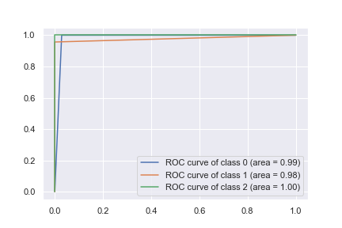

ROC KNN

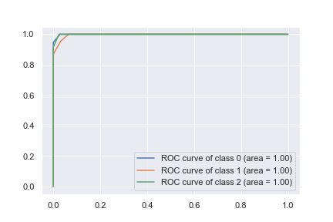

ROC LOGISTIC REGRESSION

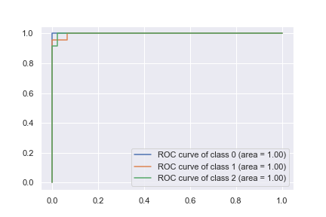

ROC SVM

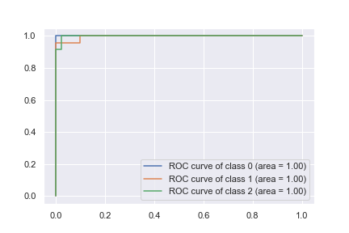

APARTAT A:

* Normalitzar les dades
* Canviar el kernel de linear i la gamma

HISTOGRAMES DELS ATRIBUTS

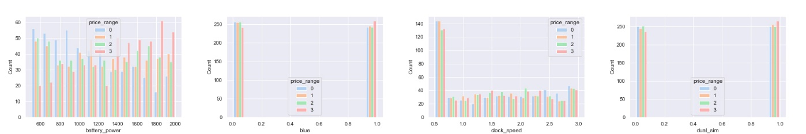

Histogrames dels atributs 1-4

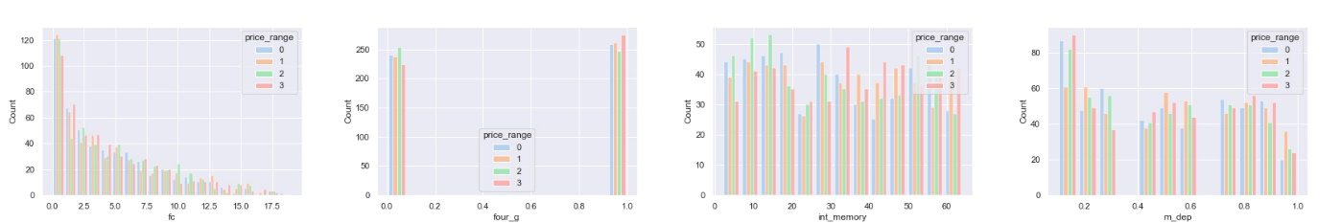

Histogrames dels atributs 5-8

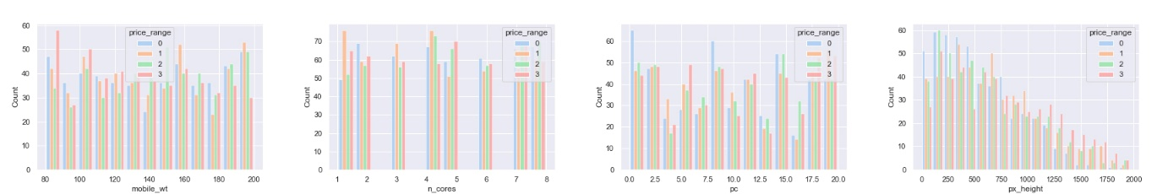

Histogrames dels atributs 9-12

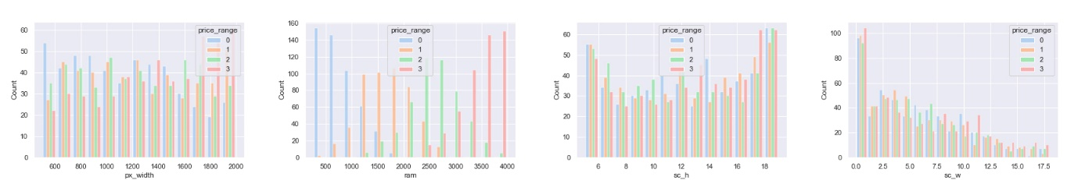

Histogrames dels atributs 13-16

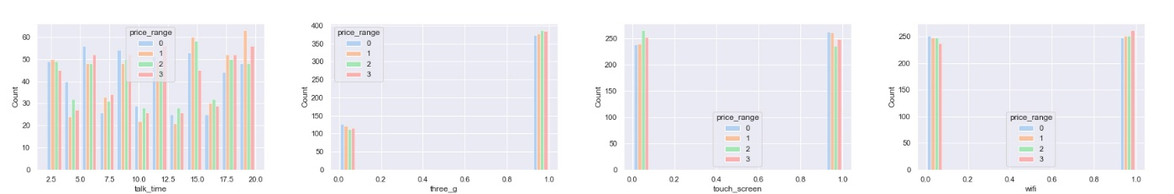

Histogrames dels atributs 17-20

GRÀFIQUES DE DISPERSIÓ

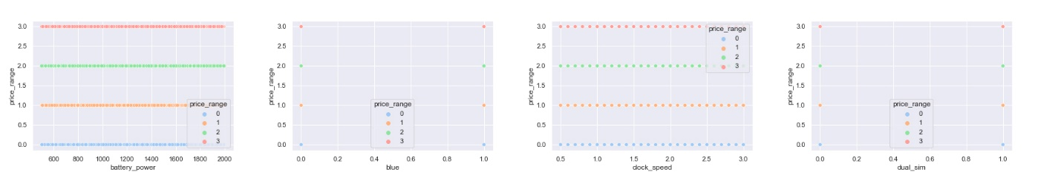

Dispersió dels atributs 1-4

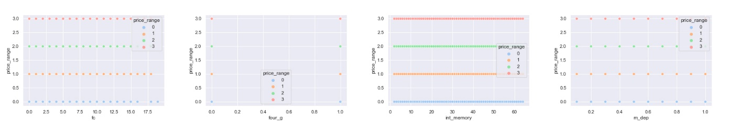

Dispersió dels atributs 5-8

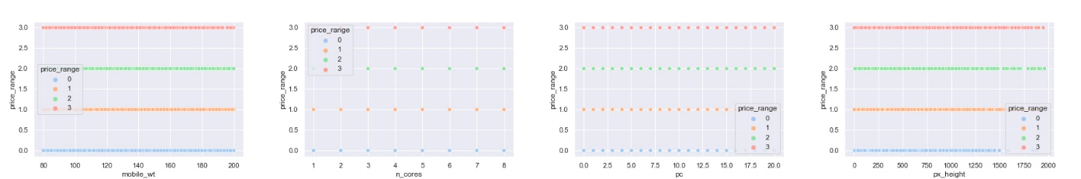

Dispersió dels atributs 9-12

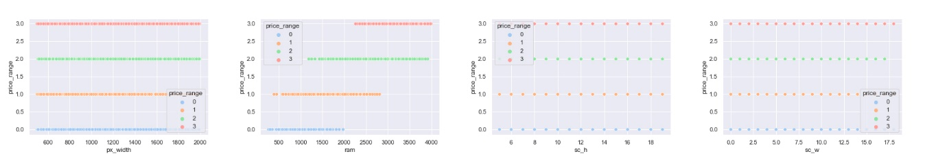

Dispersió dels atributs 13-16

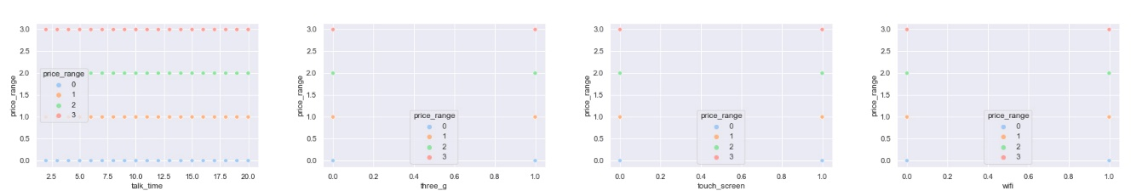

Dispersió dels atributs 17-20

Support Vector Machines

|  |  |  |  |  |  |
| --- | --- | --- | --- | --- | --- |
| Mètode selecció | Precisió | C | fit_intercept | penalty | Tol |
|  |  |  |  |  |  |
| Bàsica |  |  |  |  |  |
| 50% train 50% test | 0.943 | 1.0 | True | L2 | 0.0001 |
| 80% train 20% test | 0.9525 | 1.0 | True | L2 | 0.0001 |
| 70% train  20% test | 0.967 | 1.0 | True | L2 | 0.0001 |
|  |  |  |  |  |  |
| K-Fold |  |  |  |  |  |
| K = 2 | 0.954 | 1.0 | True | L2 | 0.0001 |
| K = 3 | 0.956 | 1.0 | True | L2 | 0.0001 |
| K = 4 | 0.9605 | 1.0 | True | L2 | 0.0001 |
| K = 5 | 0.9625 | 1.0 | True | L2 | 0.0001 |
| K = 6 | 0.9635 | 1.0 | True | L2 | 0.0001 |
|  |  |  |  |  |  |
| LOOCV | 0.966 | 1.0 | True | L2 | 0.0001 |

Perceptron

|  |  |  |  |  |  |
| --- | --- | --- | --- | --- | --- |
| Mètode selecció | Precisió | C | fit_intercept | penalty | Tol |
|  |  |  |  |  |  |
| Bàsica |  |  |  |  |  |
| 50% train 50% test | 0.943 | 1.0 | True | L2 | 0.0001 |
| 80% train 20% test | 0.9525 | 1.0 | True | L2 | 0.0001 |
| 70% train  20% test | 0.967 | 1.0 | True | L2 | 0.0001 |
|  |  |  |  |  |  |
| K-Fold |  |  |  |  |  |
| K = 2 | 0.954 | 1.0 | True | L2 | 0.0001 |
| K = 3 | 0.956 | 1.0 | True | L2 | 0.0001 |
| K = 4 | 0.9605 | 1.0 | True | L2 | 0.0001 |
| K = 5 | 0.9625 | 1.0 | True | L2 | 0.0001 |
| K = 6 | 0.9635 | 1.0 | True | L2 | 0.0001 |
|  |  |  |  |  |  |
| LOOCV | 0.966 | 1.0 | True | L2 | 0.0001 |

kNN

|  |  |  |  |  |  |
| --- | --- | --- | --- | --- | --- |
| Mètode selecció | Precisió | C | fit_intercept | penalty | Tol |
|  |  |  |  |  |  |
| Bàsica |  |  |  |  |  |
| 50% train 50% test | 0.943 | 1.0 | True | L2 | 0.0001 |
| 80% train 20% test | 0.9525 | 1.0 | True | L2 | 0.0001 |
| 70% train  20% test | 0.967 | 1.0 | True | L2 | 0.0001 |
|  |  |  |  |  |  |
| K-Fold |  |  |  |  |  |
| K = 2 | 0.954 | 1.0 | True | L2 | 0.0001 |
| K = 3 | 0.956 | 1.0 | True | L2 | 0.0001 |
| K = 4 | 0.9605 | 1.0 | True | L2 | 0.0001 |
| K = 5 | 0.9625 | 1.0 | True | L2 | 0.0001 |
| K = 6 | 0.9635 | 1.0 | True | L2 | 0.0001 |
|  |  |  |  |  |  |
| LOOCV | 0.966 | 1.0 | True | L2 | 0.0001 |

Decision Tree

|  |  |  |  |  |  |
| --- | --- | --- | --- | --- | --- |
| Mètode selecció | Precisió | C | fit_intercept | penalty | Tol |
|  |  |  |  |  |  |
| Bàsica |  |  |  |  |  |
| 50% train 50% test | 0.943 | 1.0 | True | L2 | 0.0001 |
| 80% train 20% test | 0.9525 | 1.0 | True | L2 | 0.0001 |
| 70% train  20% test | 0.967 | 1.0 | True | L2 | 0.0001 |
|  |  |  |  |  |  |
| K-Fold |  |  |  |  |  |
| K = 2 | 0.954 | 1.0 | True | L2 | 0.0001 |
| K = 3 | 0.956 | 1.0 | True | L2 | 0.0001 |
| K = 4 | 0.9605 | 1.0 | True | L2 | 0.0001 |
| K = 5 | 0.9625 | 1.0 | True | L2 | 0.0001 |
| K = 6 | 0.9635 | 1.0 | True | L2 | 0.0001 |
|  |  |  |  |  |  |
| LOOCV | 0.966 | 1.0 | True | L2 | 0.0001 |

Model Random Forest

|  |  |  |  |  |  |
| --- | --- | --- | --- | --- | --- |
| Mètode selecció | Precisió | C | fit_intercept | penalty | Tol |
|  |  |  |  |  |  |
| Bàsica |  |  |  |  |  |
| 50% train 50% test | 0.842 | 1.0 | True | L2 | 0.0001 |
| 80% train 20% test | 0.85 | 1.0 | True | L2 | 0.0001 |
| 70% train  20% test | 0.883 | 1.0 | True | L2 | 0.0001 |
|  |  |  |  |  |  |
| K-Fold |  |  |  |  |  |
| K = 2 | 0.8605 | 1.0 | True | L2 | 0.0001 |
| K = 3 | 0.8745 | 1.0 | True | L2 | 0.0001 |
| K = 4 | 0.885 | 1.0 | True | L2 | 0.0001 |
| K = 5 | 0.8795 | 1.0 | True | L2 | 0.0001 |
| K = 6 | 0.8815 | 1.0 | True | L2 | 0.0001 |
|  |  |  |  |  |  |
| LOOCV | 0.886 | 1.0 | True | L2 | 0.0001 |

Model Logístic

|  |  |  |  |  |  |
| --- | --- | --- | --- | --- | --- |
| Mètode selecció | Precisió | C | fit_intercept | penalty | Tol |
|  |  |  |  |  |  |
| Bàsica |  |  |  |  |  |
| 50% train 50% test | 0.943 | 1.0 | True | L2 | 0.0001 |
| 80% train 20% test | 0.9525 | 1.0 | True | L2 | 0.0001 |
| 70% train  20% test | 0.967 | 1.0 | True | L2 | 0.0001 |
|  |  |  |  |  |  |
| K-Fold |  |  |  |  |  |
| K = 2 | 0.954 | 1.0 | True | L2 | 0.0001 |
| K = 3 | 0.956 | 1.0 | True | L2 | 0.0001 |
| K = 4 | 0.9605 | 1.0 | True | L2 | 0.0001 |
| K = 5 | 0.9625 | 1.0 | True | L2 | 0.0001 |
| K = 6 | 0.9635 | 1.0 | True | L2 | 0.0001 |
|  |  |  |  |  |  |
| LOOCV | 0.966 | 1.0 | True | L2 | 0.0001 |